

|  |  |
| --- | --- |
| **Course Title:** | Fundamentals of Data Engineering |
| **Course Number:** | COE 848 |
| **Semester/Year (e.g.F2016)** | W2021 |
|  |  |
| **Instructor:** | Dr. Faezeh Ensan |
|  |  |
|  |  |
| *Assignment/Lab Number:* | 5 |
| *Assignment/Lab Title:* | Database Programming |
|  |  |
|  |  |
| *Submission Date:* | March 30, 2021 |
| *Due Date:* | March 30, 2021 |

|  |  |  |  |  |
| --- | --- | --- | --- | --- |
| **Student LAST Name** | **Student FIRST Name** | **Student Number** | **Section** | **Signature\*** |
| Shreekant | Vatsal | 500771363 | 01 | VS |

*\*By signing above you attest that you have contributed to this written lab report and confirm that all work you have contributed to this lab report is your own work. Any suspicion of copying or plagiarism in this work will result in an investigation of Academic Misconduct and may result in a “0” on the work, an “F” in the course, or possibly more severe penalties, as well as a Disciplinary Notice on your academic record under the Student Code of Academic Conduct, which can be found online at:* [*http://www.ryerson.ca/senate/current/pol60.pdf*](http://www.ryerson.ca/senate/current/pol60.pdf)

The Lab5 project should be compiled in run in a Java IDE as it was developed in NetBeans.

Open the project library and run lab5.java. The JDBC driver was used to connect the Amazon.db to the Java application and access the queries.

To run the queries, simply first run the lab5.java. The output window will then ask for the user to enter a number from 1 to 10 (each number assigned to each query). Upon entering any of the 10 numbers, the program will output the selected query from the Amazon.db database.

The following values and data types were built in conjunction with labs 1, 2 and 3.

Queries Selection:

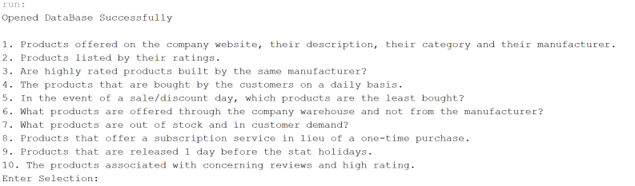

Figure 1: Query Selection Interface

The 10 queries:

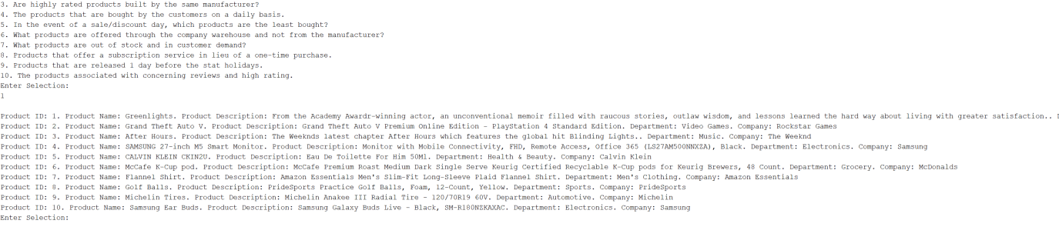

Figure 2: Query #1: Products offered on the company website, their description, their category and their manufacturer.

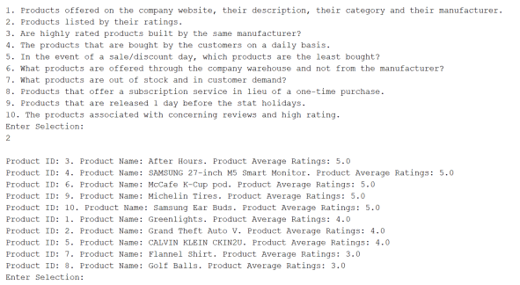

Figure 3: Query #2: Products listed by their ratings.

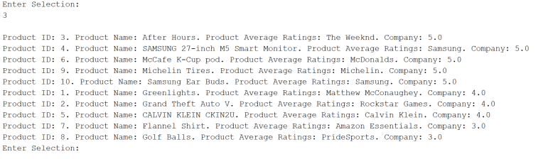

Figure 4: Query #3: Are highly rated products built by the same manufacturer?

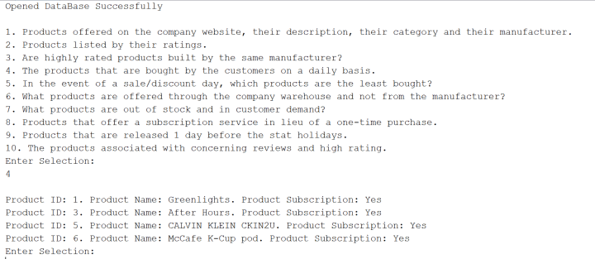

Figure 5: Query #4: The products that are bought by the customers on a daily basis.

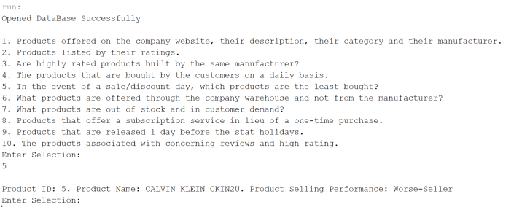

Figure 6: Query #5: In the event of a sale/discount day, which products are the least bought?

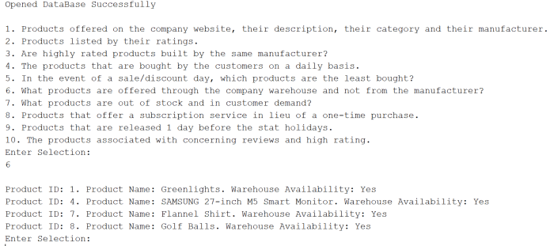

Figure 7: Query #6: What products are offered through the company warehouse and not from the manufacturer?

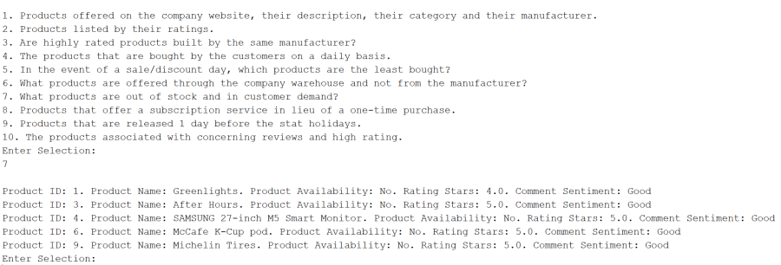

Figure 8: Query #7: What products are out of stock and in customer demand?

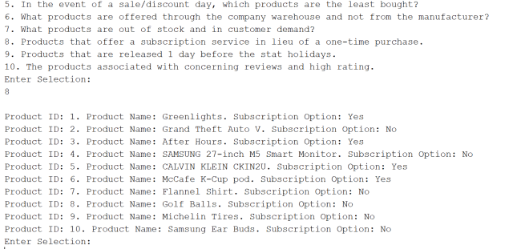

Figure 9: Query #8: Products that offer a subscription service in lieu of a one-time purchase.

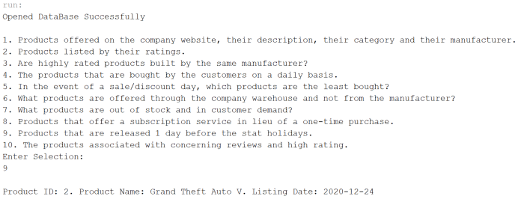

Figure 10: Query #9: Products that are released 1 day before the stat holidays.

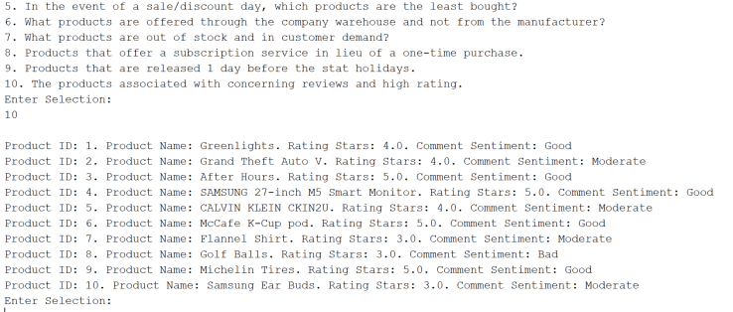

Figure 11: Query #10: The products associated with concerning reviews and high rating.